

North South UniversityDepartment of Electrical and Computer Engineering

Project Report

”Online Makeup Shop”

CSE311L Database System Lab  
Semester: Spring 2022 Section: 9

Project Group InformationJahirul Islam 2021948642  
Tamanna Rahman 2021450642

Course FacultyNadeem Ahmed

Lab InstructorNazmul Alam Dipto  
Submission Date: April 25, 2022

**Introduction**

The online makeup shop web portal developed to display and sell makeup products online. This will be full-fledged e-commerce site where customer can purchase product, add product to shopping cart. System administrator can add new product from the web interface. The main aim of this project is to manage all the details about product, customer and sells etc. There are two types of users available in the project, first one is customer and second one is Admin. In this project user can do sign up with an e-mail, password. They can buy product; user also can do add to cart multiple products. Admin can log in to profile and add makeup products, product types, price, description and view order information etc. All products will be managed by admin and customer will be able to purchase products. Also, admin can see the stock of the products. All the data of this website will be managed by database

system.

**Background Research**

There are several reasons why people and especially the female gender are so much inclined towards makeup. Some of us apply it for having a more natural look, while many people love to play with colors and keep experimenting with their look. Whatever the reason may be, we can’t deny that makeup is something that every woman loves to use and likes to have a collection of more such products.

Apart from the fact that makeup is only used for beautifying, it also has several importance. Mentioned below are some of the reasons that show why makeup is important for us.

Saving time. Of course, shopping takes a lot of time and effort. Using the same virtual store, you can, without leaving your home, at any convenient time of the day, sit down at the monitor, and calmly choose the product of interest.

**Technologies**

Tech stack that has been used in the project:

* HTML
* CSS
* PHP
* MySQL

**Project Design**

**Description of users:**

There are two types of users. Only admin has the more power than users and users individual roles and features are given below in the table form.

|  |  |
| --- | --- |
| User Type | Role |
| User | • Can buy all the makeup item and browse items. • Customer can see their total bill. • Customer can edit their profile. • Items can be added into the cart.  • Place the order. • In cart item customer can change the quantity of item |
| Admin | • Login For Admin • Logout Functionality • Dashboard for Admin User • Admin can manage the product • Admin can edit/delete the product • Admin can see the list of all product • View details of the Product • Customer can see product |

**ER Diagram:**

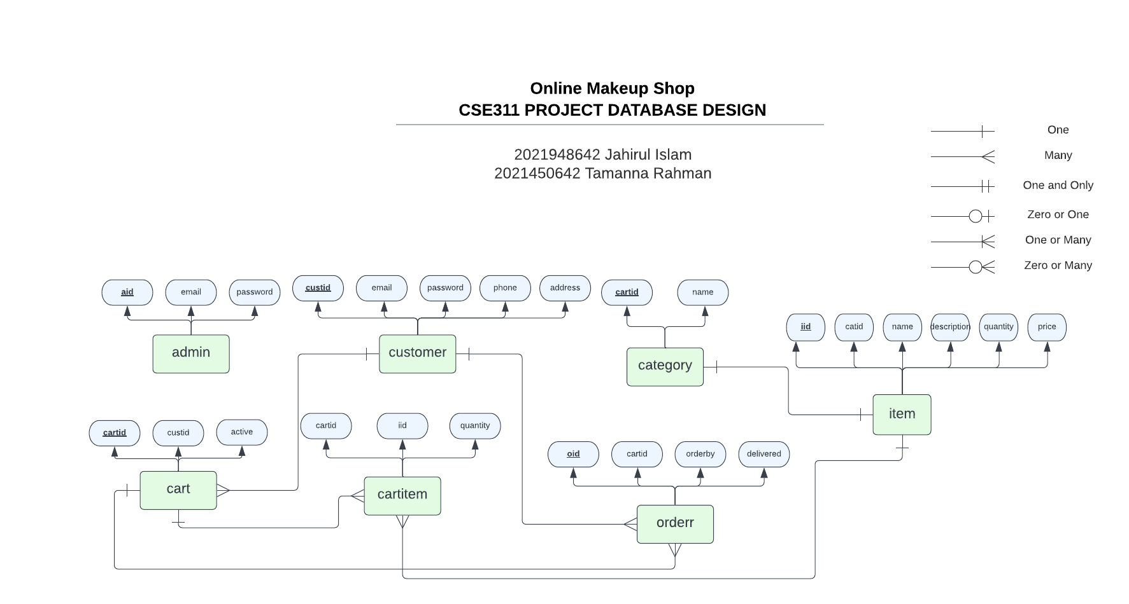

**Relational Model:**

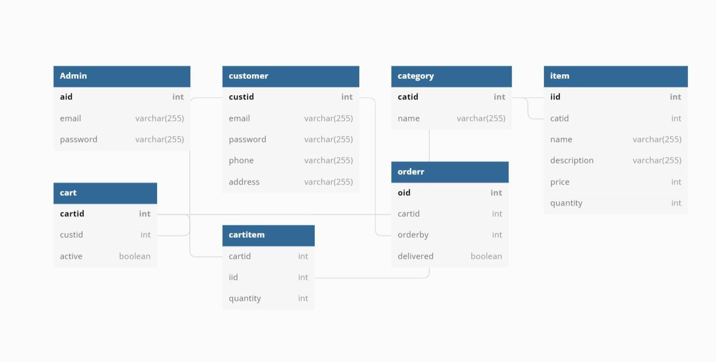

**Use Case :**

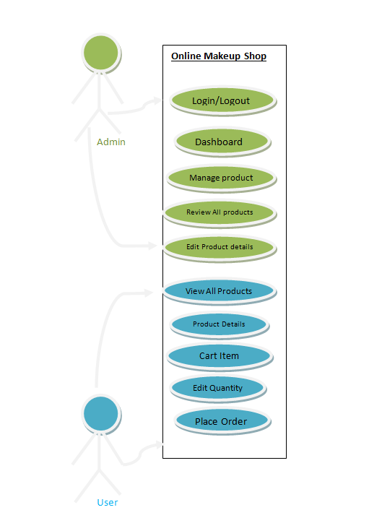

**Sitemap**

Index.php

Viewproduct.php

adminlogin.php

admindashboard.php

addnewitem.php

edititem.php

vieworder.php

orderdetails.php

userlogin.php

cart.php

logout.php

**Snapshots**

User Login Page (customerlogin.php):

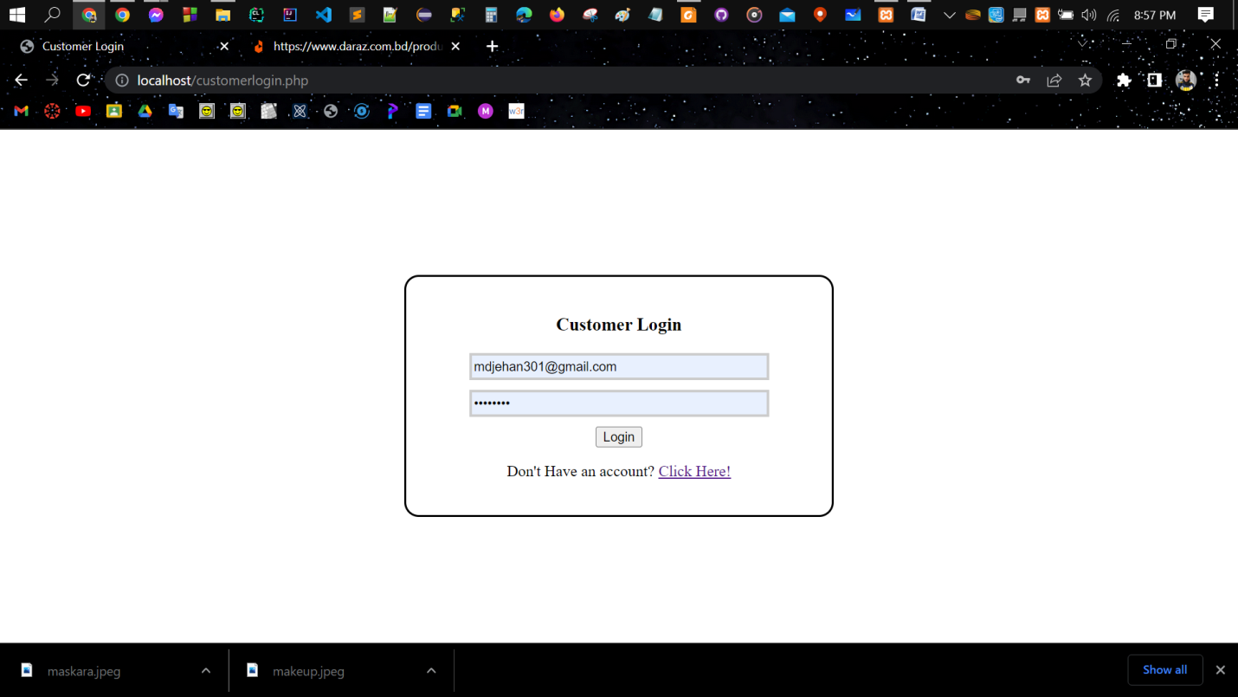

Signup Page (customersignup.php):

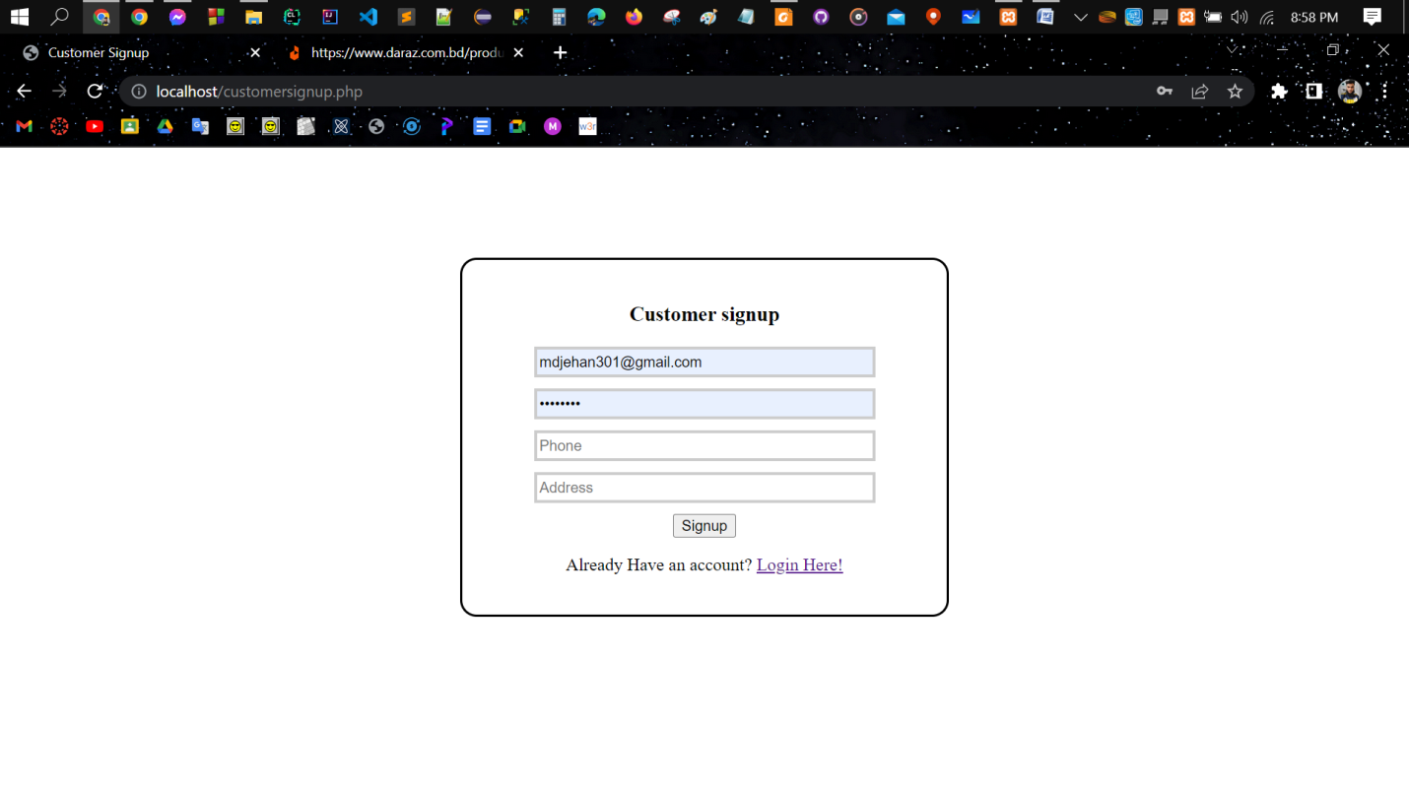

Admin login page (adminlogin.php) :

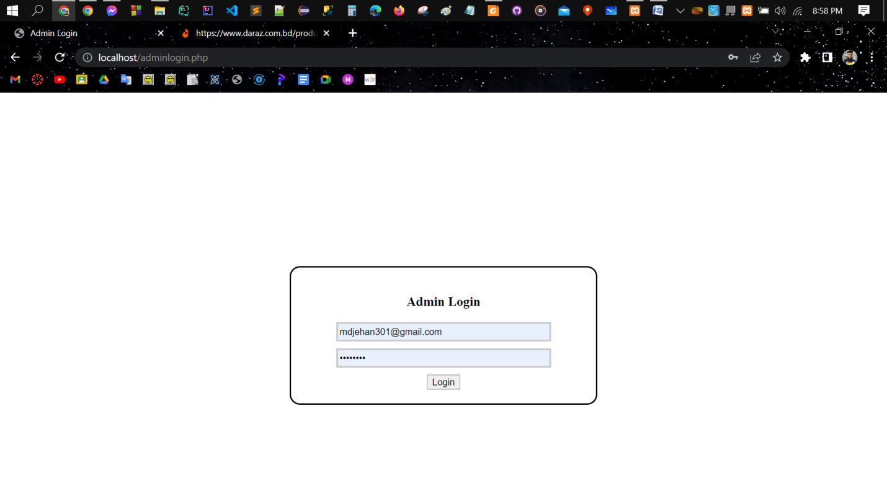

Admin Dashboard (admindashboard.php) :

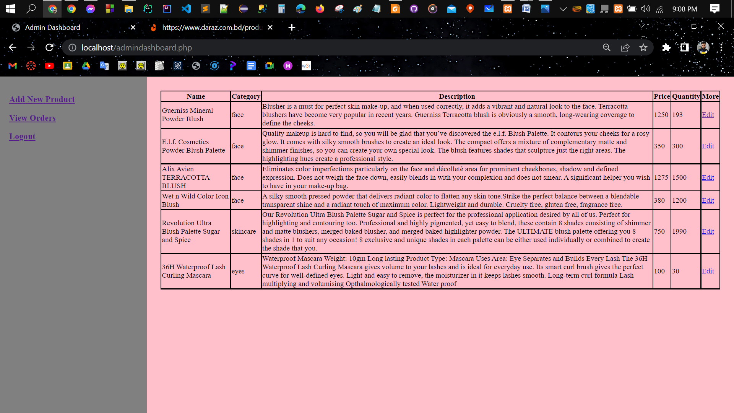

Admin View Order (vieworder.php) :

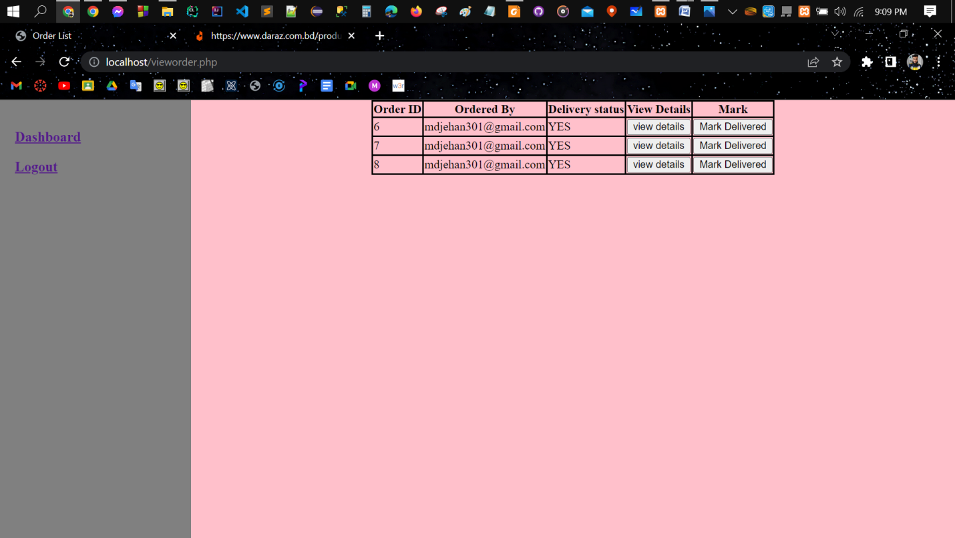

Adding New Product (savenewproduct.php) :

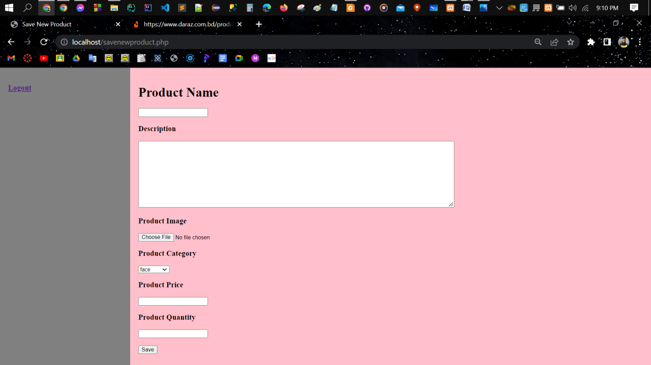

Edit Product Details (editproduct.php) :

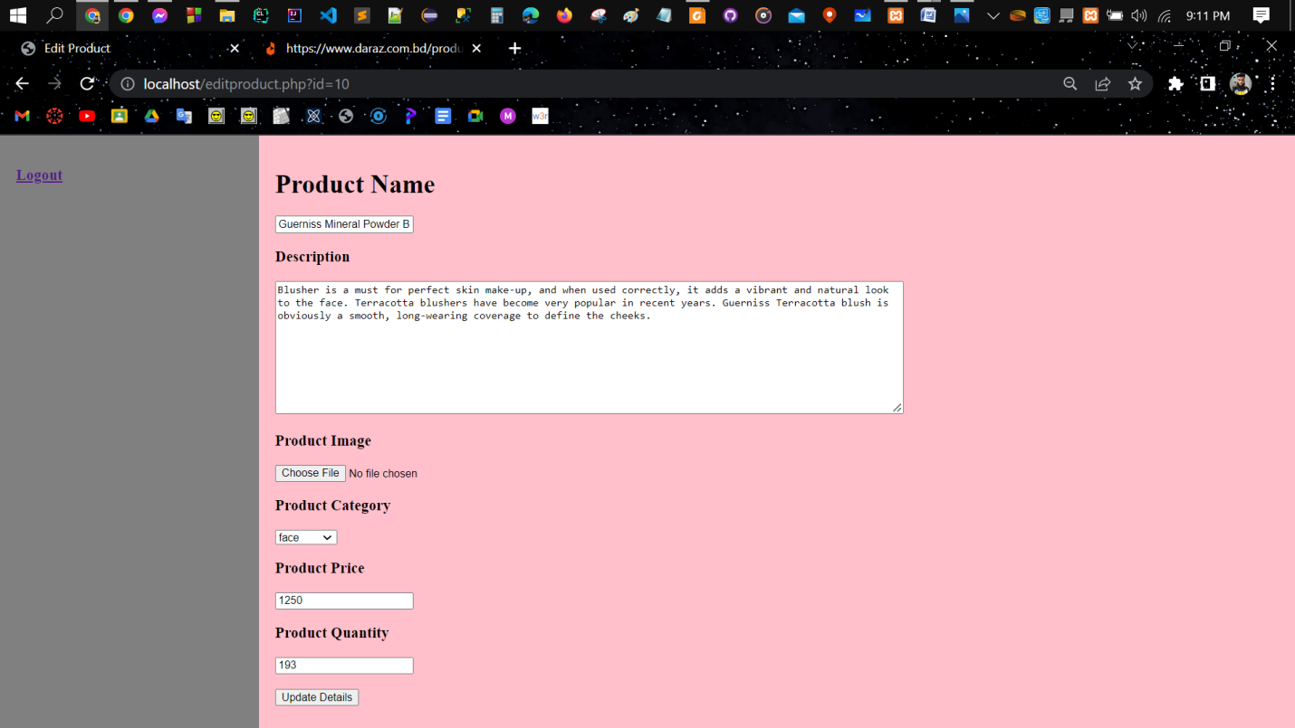

Home Page (index.php):

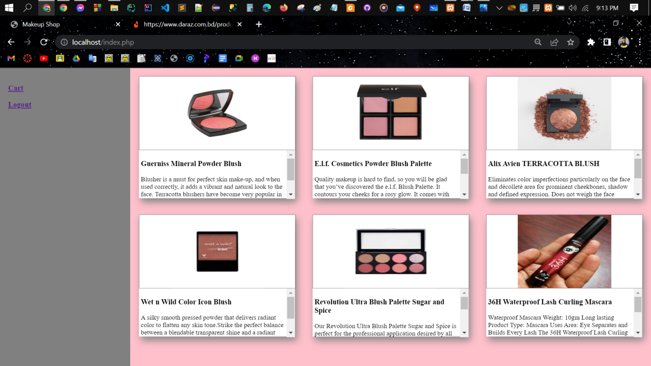

View Product (viewproduct.php) :

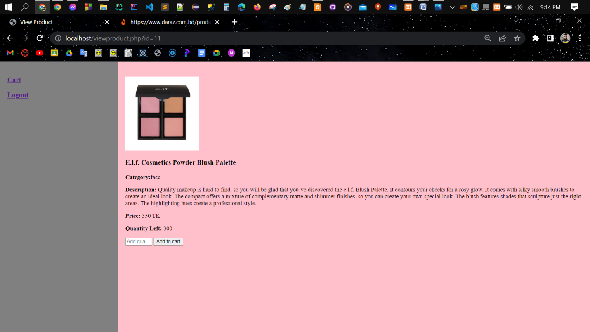

Cart Item (cart.php) :

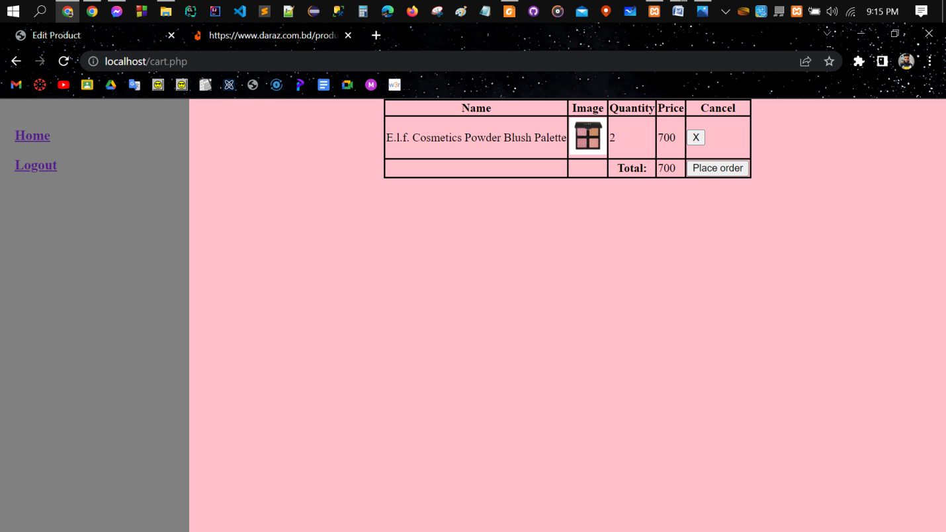

**Conclusion & Future Work**

**Project success and findings:**

This project has been completed with all the requirements needed. Our web is ready for use and we can see correct output or resulting data from our web application. This project has been tested against several test data and our output was accurate.

**How this web application can be improved:**

This web application can be improved by applying tools and technologies for large scale of data. There can be implement better queries and reduced time complexity. That will be more efficient for this application. Also, user interface can be improved, its real time technologies can be developed.

**Contributions**

Jahirul Islam 2021948642

Contributes in integrating front-end with back-end and front-end design layout

Tamanna Rahman 2021450642

Contributes in back-end functions, database design and documentations